Hi Tom and Carsten,
For the supervisor meeting tomorrow, we have prepared a few pages in the report:
Section 5.5 Convexity on pp. 60-61
Appendix - Unit conversion - WT Hydraulic Capacitance on p. 75
Section 4.7.1 Discretization of SS model on pp. 44-45.
We have been working on the simulation, but are having some problems.
Here we will explain how the simulation is build up and what our problems are. Everything you see here is also attached, if you have time to look at it. If you download the folder you should run Initialization.m and then either simulering.slx or simulering_2016b.slx.
The structure of the structure of the implementation can be seen here:
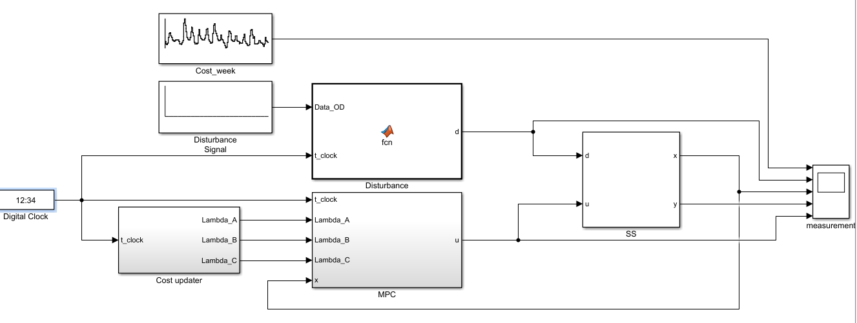
Figur 1
The “Digital Clock” is just at clock that outputs the time with our sampling time. We use this to keep track on then the Disturbance, Cost and MPC need to be updated.
The “Cost updater” updates the Lambda_A/B/C matrices every hour. More detailed this is done by loading in the system matrices, including the estimated matrices, and the cost function. This block also use the Digital clock to keep track at the current time so the right part of the weekly cost model is used of the Lambda matrices.
The “MPC” is the optimizer. Here the, extended, system matrices, disturbance and constraints are gathered to a standard quadratic problem. The optimizer function “fmincon” is used to solve the problem. For each iteration, the first value of the predicted optimal control input, u, is pick out and send to the SS model.
The “SS” is the state space model of our system. See figure below. The discretized matrices are setup as a standard state space system with disturbance on the both the state and the state and output.
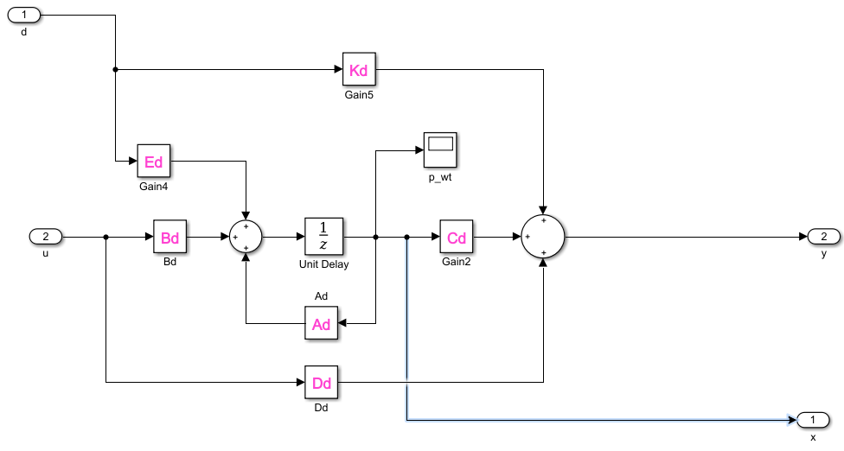
Figur 2
The “Disturbance” box is simply made to loop the 24-hour disturbance model so the next 24 hours from the current time step is chosen. In this simulation, the disturbance is chosen to be constant until we have something working.
The problem:
In the left side of the first picture you can see that se plot cost, disturbance(d), pressure WT(x), pressure CP (y) and control input (u). All signals except the cost are small signal. Here it can be seen that the pressure WT(x), pressure CP (y) and control input (u) are all constant even though the price changes, ref pic 3. Or at least they seem constant, but then we checked if the MPC script worked like expected, by including breaks in the matlab code and displaying/plotting variables during an irritation. It all seemed to be in order.
Then we took a closer look at our results and figured out that all three variables, pressure WT(x), pressure CP (y) and control input (u), wasn’t constant, but the variation is very small. In figure 4 when the cost is increasing, the control signal u is decreasing, just as we want it to. But are the same time as u Is decreasing the pressure in the WT is increasing, which of course make no sense.
So overall u follows the expected path but we have two problems, 1) The value of the control signal is way too low, so the impact on the WT is very low. 2) The dynamic of the WT is wrong, it increases when we expect it to decrease.
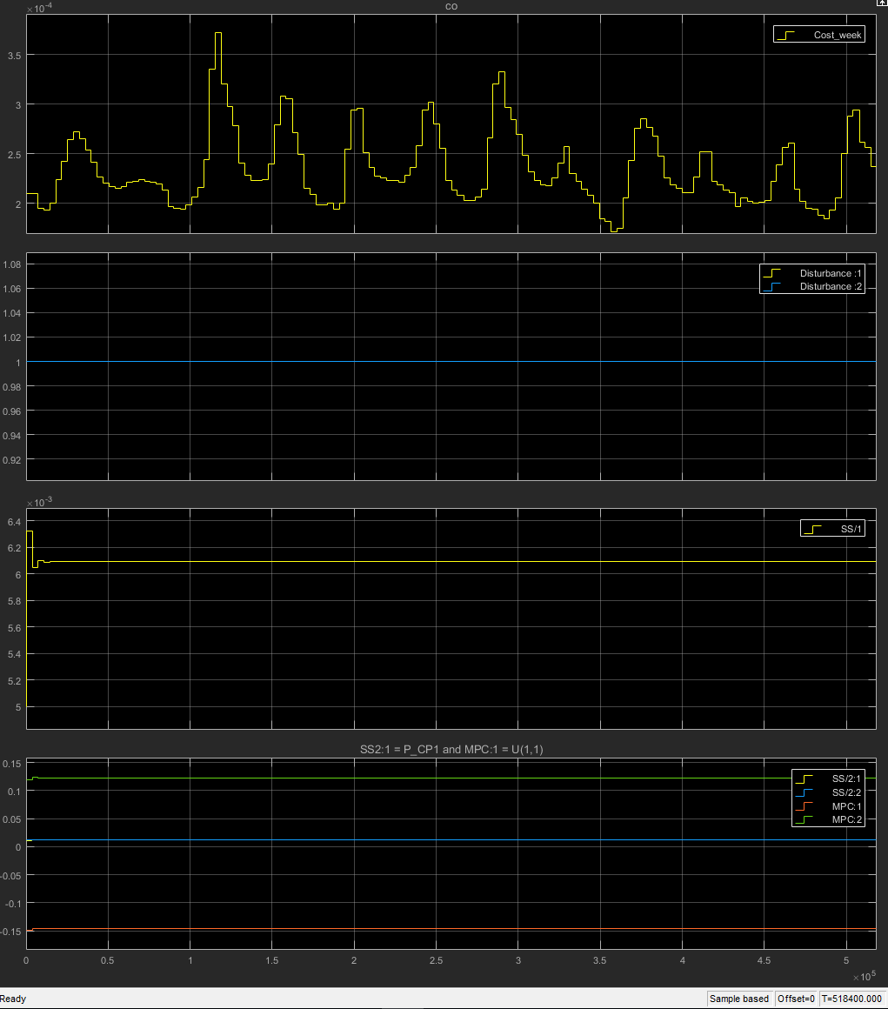
Figur 3
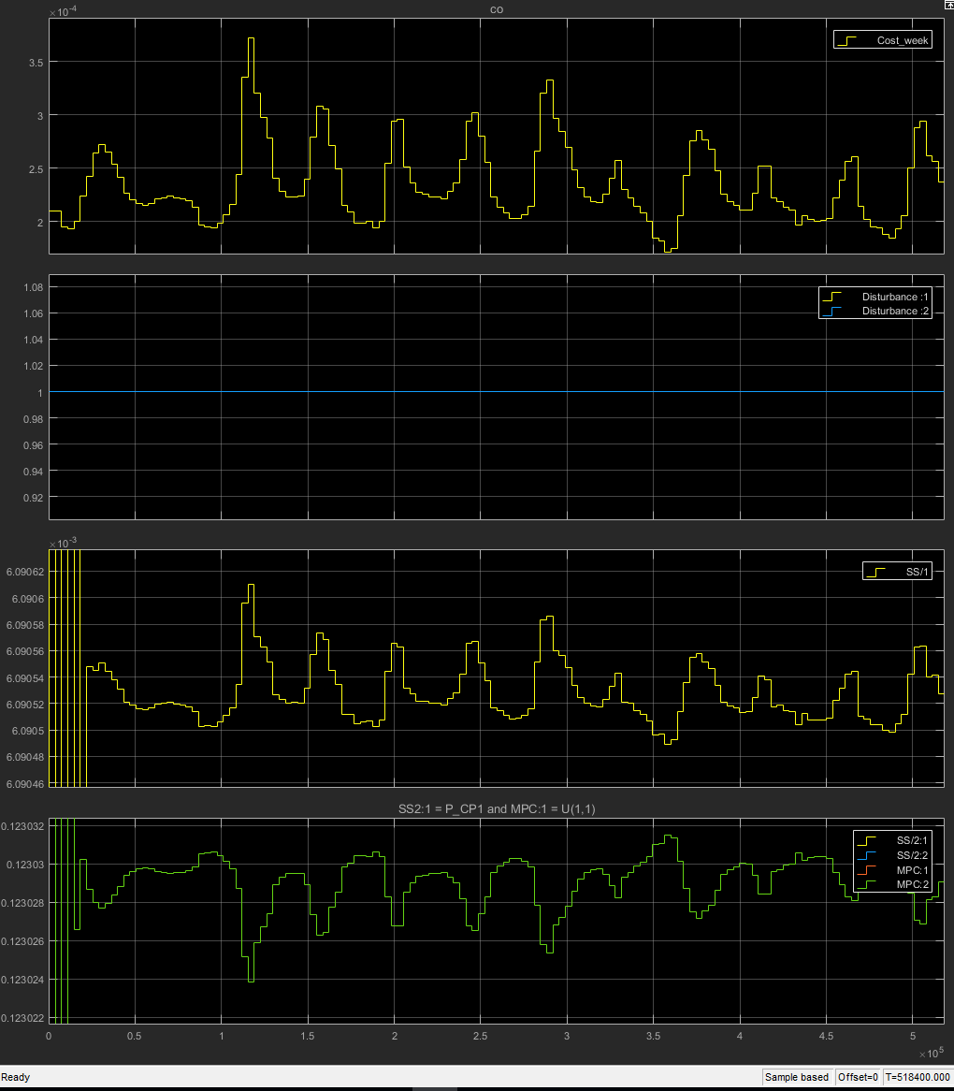
Figur 4

